Ngày thực hiện: 30/03/2016
Số tiết: 1

UNIT 2: IS THERE A BANK NEAR HERE?

READING: SHOP TILL YOU DROP?
Main skill: Reading
Objectives: By the end of the lesson, students will be able to:
+Reinforce students’comprehension skill.
+Practice skimming and scanning skill in reading
+Define the meaning of the words in the article
+Share ideas and participate in a classroom discussion
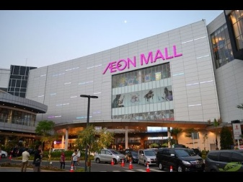
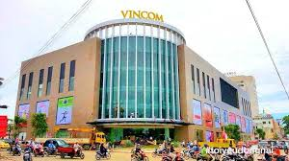

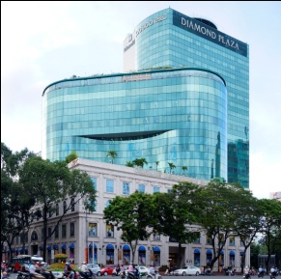
Teaching aids: pictures, blackboard, textbook, cassette, chalk, handouts
LESSON’S CONTENT | TIME | TEACHER’S ACTIVITIES | STUDENT’S ACTIVITIES
Pre-reading:  Warm up  While- reading  Post- reading | 10 mins  25 mins  15 mins | -Greeting.  -Teacher (T) asks Students (Ss) to close their books first.  -T shows photos of some famous shopping malls in Ho Chi Minh city and asks students to guess.  -T shows photo of The Mall of America.  -T gives some extra information of The Mall of America.  -T asks some questions  “What do you often do in your free time”  “Where do you usually go to buy your clothes”  -T writes the title of the article “Shop till you drop?” on the board.  -T explains the title of the article.  -T has students open their books.  -T explains what entertainment, store, indoor amusement park, aquarium mean.  - T models to read aloud each word.  -T calls some S to practice pronouncing the new words.  -T asks students to find these words “retail area, combined total, as long as a soccer field, and the entire mall” in the article and underline them.  -T asks students to do Activity 2.  -T gives feedback.  -T asks students to focus attention on the questions in Activity 3.  -T asks students to explain the meanings of phrases “beside stores, tourist attrations, foreign visitors, sea life”  -T plays the recording  -T has students read the article individually.  -T asks a representative of each group to go on the board and write down the answers.  -T gives feedback  -T writes the questions on the board  “Are there any large shopping areas near you? What are they like? What else can you do there?”  -T divides students into the small groups of 3.  -T gives students 5 minutes to discuss in group.  -T gives some suggestions. For example, a place that is well-known for tourism, and then compares it with the Mall of America.  -T elicits answers from each group and writes them on the board. | -Students close their book.  -Ss look at the photos and answer.  Expected answers: Diamond Plaza, Aeon Mall, Vincom Plaza, Lotte Mart  -Ss answer the questions  Expected answers  -Go shopping  -Go to mall to buy clothes  -Ss open their book.  -Ss pay attention on those new words on the board.  -Ss practice pronuncing new vocabulary.  -Ss do Activity 2  Expected answers  1 c 2 a 3 d 4 b  .  -Ss listen the recording.  -Ss answer these questions individually  -Ss write their answers on the board.  Expected answers  1.Seven nightclubs, an indoor amusement park, an aquarium, and Cam Snoopy.  2.Walt Disney World and the Grand Canyon.  3.About 13,000 people work there in the summer.  4.Visitors from the UK, Japan, and Europe go there.  5.In the underground tunnel.  -Ss discuss questions in group.  -Ss write down their answers on the board and compare with other groups.  .
TỔ TRƯỞNG BỘ MÔN GV SOẠN

Nguyễn Thị Minh Quý Phạm Thị Thu Hiền

